E-portfolio

jules buvens

Robotics

Vision impairment



**Onboarding week 1:**

My name is Jules Buvens and I am 20 years old. I live in Beringen, which is in Belgium. I study finance & insurance in Diepenbeek at UCLL. After my studies, I might want to continue studying but I'm not sure yet. In my spare time I do a lot of sports, I often go jogging and in summer I cycle a lot. My interests are very much in football and cars but also in stocks and crypto. My favorite car brand is BMW and my favorite football club is KRC Genk, which is a Belgian club. In my spare time, I also like to party with my friends.

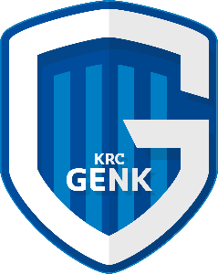

I have also a cat, her name is Billie. She looks very sweet but sometimes she can also be naughty.

My strengths are mainly that I am flexible and reliable but also organized and entrepreneurial.

I signed up for an I living lab because it seems very interesting for me to collaborate with people I don't know and from other countries on a topic I don't have much knowledge about.

What motivates me hard is that I have to work on a totally different topic from my field of study. And this is only going to expand my knowledge. After all, I know almost nothing about this subject yet either.

**Onboarding week 2:**

The kick-off was interesting because I didn't know much about the living lab before and this give me more clarity. I also liked that we could get to know our little group. We got to know each other already and this was very cool.

My reflection partners are Zack and Geovana. I will observe Zack and Geovana will observe me.

The self-elevation about my future skills went well, but it was difficult at times. I found this very informative because it helps you get to know yourself a bit more.

I chose communication because I want to speak better English but also listen to people better. I also chose design thinking because I am not creative at all and I want to get stronger at this and you do need to be a bit creative to succeed in this ILL. The last skill I chose is self determination. A third skill was difficult to choose but I chose this one because I want to tell the group more about my own choices.

My current level for communication is not bad but my English is very basic and I want to feel more comfortable speaking another language. I can't think design very well at the moment so I want to become more creative and really help come up with ideas. The last skill was self determination, I can make my own choices at the moment but not enough yet I want to be able to do this perfectly and always tell my ideas to the group.

I have already started looking for info on robotics and there are a lot of possibilities but first we need to start thinking what our target audience is. This could be blind people but also deaf people as well as people with autism.

I will mainly focus on good and fun cooperation in my group.

**Week 1:**

*How was the 2. Onboarding Week for me? How did we as a Team begin?*

The onboarding weeks are behind us and I found them very interesting. We got to know each other better using fun basic questions like what did you eat this morning or what 3 things would you take with you to an island. So we got to know each other better in a fun way. In the beginning, I found it a bit difficult to get used to speaking English all the time but once you get started, it goes more smoothly. I think we have a very nice group and everyone dares to talk and that's good. I am definitely looking forward to the next few weeks and I am curious about our final result. we first got to know each other and now we start thinking about what target group we want to come up with something for.

*Who is my new reflection partner?*

My reflection partners are Zack and Geovana. I will observe Zack and Geovana will observe me.

*Which skills, knowledge, strengths will help me with the DT Process?*

I am someone who always completes his tasks on time and also tries to do it the best he can. I also really like helping people so if someone is in trouble with something I am always happy to help. I don't have that much knowledge about robotics for disabled people but I do like looking things up on the internet for example. That's the most important thing I think, I like to help people so also people who are disabled for example and can't do something very well anymore. I’m going to do everything I can to help that person so I would also like to come up with something nice for this ILL.

*What did I learn?*

I learned this week what it's like to work in a group with people you don't know. It is super important to have respect for each other and to listen to each other. Group work goes much better when everyone feels at ease because then everyone dares to share their ideas.

*What surprised me?*

I thought beforehand that we were being taught and that it was all super serious and a bit boring. None of this is. Our teacher says it himself "I'm not here as a teacher but as a coach". This did reassure me because you are already in class all day during the day and then again in the evening but this is totally different.

*My sparkling moment*

While coming up with rules in our group, I made a little joke and many had to laugh and that was a nice moment though.

*What have I found out in my desktop research?*

I have been looking for possible target groups that we can think of something for. There are many possibilities for blind people but also for deaf people or people with autism.

*What will I focus on next week?*

Next week I am going to focus on communication and especially listening. Next week we are going to think about what our target audience is few people will have different ideas so that is why it is important that we listen to each other respectfully so we can choose the best idea.

**Week 2:**

*How was the 1. ILL Week for me?*

I found this week an interesting and instructive one. We did some introductory questions again in group of 2 at the beginning of the session. Through these questions, you get to know each other better and better each week.

We had been instructed to give feedback on your reflection partner's portfolio. I got feedback from Geovana and I gave feedback on Zack. Everyone makes this in their own way and that makes it fun because everyone's portfolio looks different.

Then we discussed together with the group what our target group is going to be and how we are going to approach it. So we are now really going to start our design soon because we now know roughly who we want to design something for, namely people with visual impairment. This discussion went really well, I think we have the perfect group to bring this to a good end.

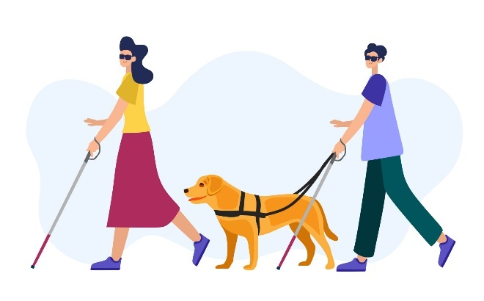

*What did I learn while reading other Portfolios?*

Everyone's portfolio looked different, which makes it fun to read them. Reading other people's portfolios also did give me inspiration of how to mention certain things next time.

I got to know my group better by reading the portfolios because everyone presents their own and you can also immediately see who is very creative and who is a little less so. This only makes it easier to work together because that way you know what someone is a little less strong at and that can be taken care of by those who are strong at it.

*What did I learn?*

I have already learned a bit of design thinking this week. This is something I am going to focus a lot on in the coming weeks to get better at it. We had to think about a target audience and also come up with ideas already. These were, for example, smart walking sticks or glasses where text comes in for the deaf so they can read it.

The ideas I came up with, already have to do with design thinking so this is what I mostly learned this week.

*What surprised me?*

What I have really noticed this week is that everyone in our group is very passionate and enthusiastic about the project. That only makes it more fun to work together. This also means that everyone is going to do their best.

During the session, we were talking about family members or any acquaintances who have disabilities and what struck me there again is that everyone knew someone like that. This conversation made everyone even more driven to design something good.

*What will I focus on next week?*

I am going to focus mainly on design thinking next week. This is something I want to get stronger at. Next weeks we are going to have to think about our design because we now know what our target audience is. When we start thinking and discussing a particular design, it's helpful that you can do good design thinking so that's why my focus is on that.

*Which creative methods have I / we applied last week? How did that go?*

We sat down with the whole group to **brainstorm** a target group and also possible ideas for that target group. This went really well because everyone had already done their research a bit so everyone could tell us an idea.

I did research by looking for information on the internet. I wanted inspiration because I am not the most creative person. By also watching YouTube videos, I got a little better at it. Because we discussed with the group, I also started to **think** better about **design**.

**Week 3:**

*How was the 2. ILL Week for me?*

This has been the most interesting and instructive week for me. On Monday, we thought together as a group about how we are going to approach it in terms of interviews. We decided that we would look for people who have an eye impairment and interview them. Once we have conducted the interviews, we will find out more about these people and then we can use the answers to think about what we are going to design.

We have created a document where everyone can put in their questions that we are going to use for the interview. The next step is to pick out the best 8 or 9 questions and we will then use these.

This week we have already made a lot of progress in the project because we are now really moving on to the practical side, namely conducting the interviews. Once these are done we can really start designing.

The meetings were fun and informative because everyone is very motivated to work on it and we also know each other better by now so that makes it more fun to work together.



*What have I found out about my reflection partner?*

My reflection partner is Zack and I immediately realised that he is very creative. He makes very good portfolios and he articulates everything very clearly.

He cooperates very well from the beginning and he comes up with good ideas. Zack is very motivated to design something well and that is very good for group work.

*Which skills, knowledge, strengths have I used already in the DT process?*

* 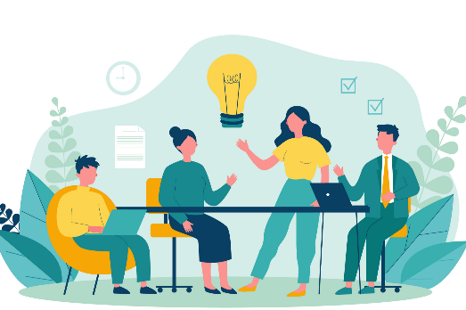Brainstorming
* Do some research
* Communication/ listening
* Work in group

*What did I learn?*

This week, I learnt more about different disabilities you can have on the eyes. Our project is about blind people or people with eye impairments. While looking up information, I learnt a lot about different forms of eye impairments. It's not just being blind but there are many other disabilities like colour-blind but also blurred vision and much more. Most of all, I have been learning what exactly these impairments are and based on this info, I have prepared questions.

*What surprised me?*

It still amazes me how cooperative everyone is. A month ago, we didn't know each other and now we are working together on a project about something completely unrelated to our fields of study.

We had already come up with quite a few questions for the interview and the teachers gave positive feedback on these, they thought these were very good questions. I also thought these were very good questions but it is still always exciting, what the teachers think of them. We are also told every week that we are a super good group and this is nice to hear. This gives us more self-confidence and this makes us work together even better.

*What feedback did I get until now?*

My reflection partner is Geovana and she has already given feedback on my portfolio a few times. My portfolio looked good, everything was clear. It was short but clear. I had in the second week, improved the layout. I had added a lot of photos and also a start sheet and I got positive feedback on this too. It looks much more professional now.

*What will I focus on next week?*

I am going to focus on research and brainstorming next week. We are now at a stage where research is very important. First, we need to have good questions for the interview and, of course, we also need to learn more about certain designs that already exist.

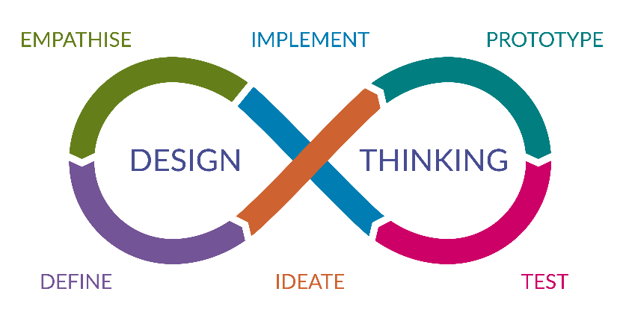Brainstorming is also very important right now both for questions and design.

Design thinking is also something I will focus on in the coming weeks. The whole project revolves around design thinking so this is where my focus is also hard.

*How did Define phase go for me and for my team?*

This went very well, everyone helped and reflected on a particular disability.

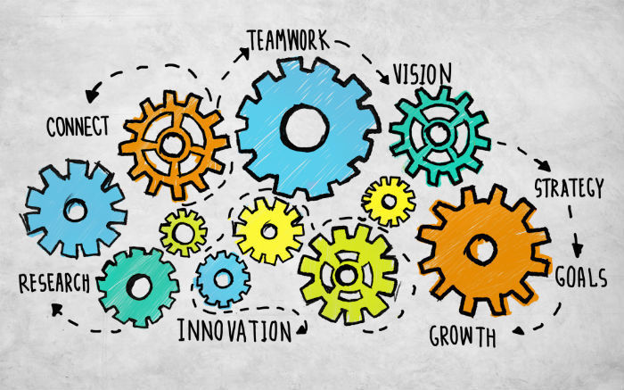

**Week 4:**

*What progress did we make in the previous week?*

This week we discussed the results of the interviews we did and also the information we found on the internet. Now we can start coming up with a problem, because before we come up with a solution, it is of course important to have a problem first.

*What was my contribution to that progress?*

I looked up information on the internet because I didn't find anyone I could interview with right away. I found a lot of information about blind people and also possible problems. Next week we will put all the problems together and then we will decide which problem to choose.

*What did I learn?*

Through the information I found on the internet, I learned a lot about blind people. I never used to think about it but being involved in our project now has made me think more about blind people. I cannot imagine what it is like not to be able to see but through the information I have found I am finding out how many problems these people have and that they really need solutions.

So in a nutshell, what I learnt this week was mainly that blind people are in great need of solutions because there are so many problems.

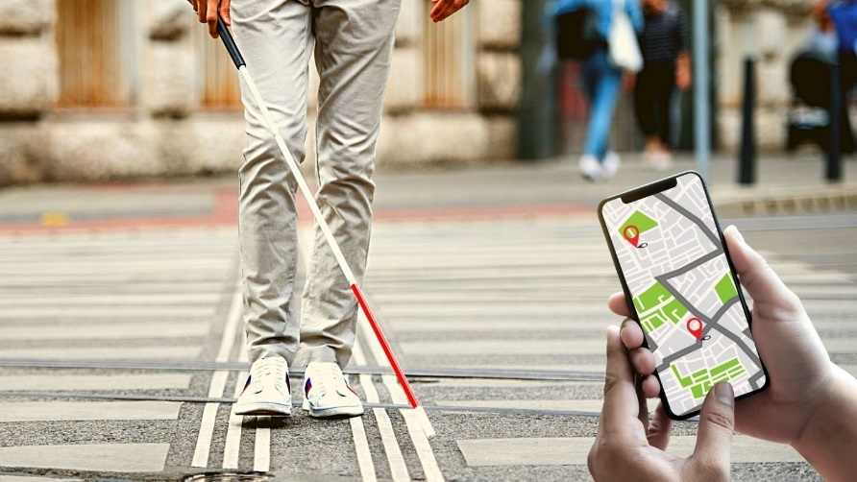

*What did I learn about pitching?*

/

*What surprised me?*

What surprised me again this week is that everyone is very motivated to work on this. Everyone looks for information and we often talk about the information found and so we get further and further every week because everyone says what they think and so we always put the most important information together so that we can easily find everything next time.

*What was my contribution to the pitch? What will we adopt/change for the final pitch?*

/

*What will I do differently next week?*

Next week, we will decide which problem to choose so that we can come up with a solution for it. So it is very important that everyone says their thoughts and wants to discuss this. I'm going to say my thoughts a bit more next week, I did this last weeks too but I didn't always do this. I'm going to say what I think more often because this is obviously important for the next steps.



**Week 5:**

*How is the cooperation with external stakeholder working?*

/

*What feedback did I get from my reflection partner?*

Geovana said she really liked my portfolio. My answers are sometimes short but always very clear and I also tell everything we did. She also said that the photos I add add value to my portfolio.

*Where & how am I going to apply this feedback in the future?*

I am very grateful to Geovana for the feedback I receive. I can definitely apply it in the future as well. I now know better how to write a good portfolio because of the feedback I got. It doesn't always have to be super elaborate but short and clear is also good. In the beginning, my layout was a bit boring and because of the feedback I've received, I've started getting more involved in the layout, so adding photos and things like that.

*What did I learn?*

This week we have been thinking about a problem we want to create a solution for. The problem we have taken is that blind people cannot read the information in bus and train stations so they cannot read which bus to take and what time it comes. So I have also been thinking a bit about a solution to this. I've been brainstorming and looking up information on the internet. So this week I really learned to think out of the box.

*What surprised me?*

What has surprised me this week is that everyone is creative. Everyone in the group comes up with original ideas. We are now in a phase where we have to come up with a solution to the problem we have and then we do have to start thinking creatively and I thought at first that this was not going to be so easy but this is going super well. Everyone is giving good ideas.

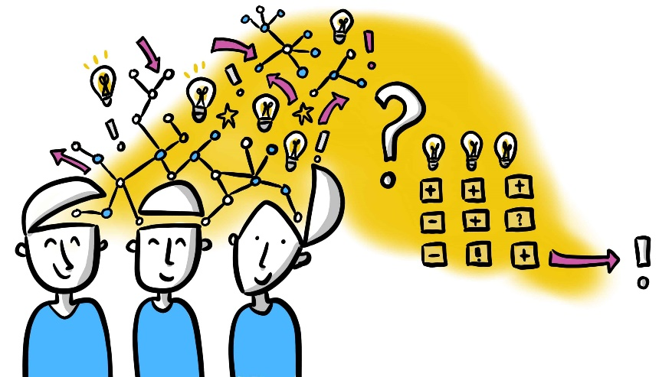

*What are we preparing for the final pitch?*

/