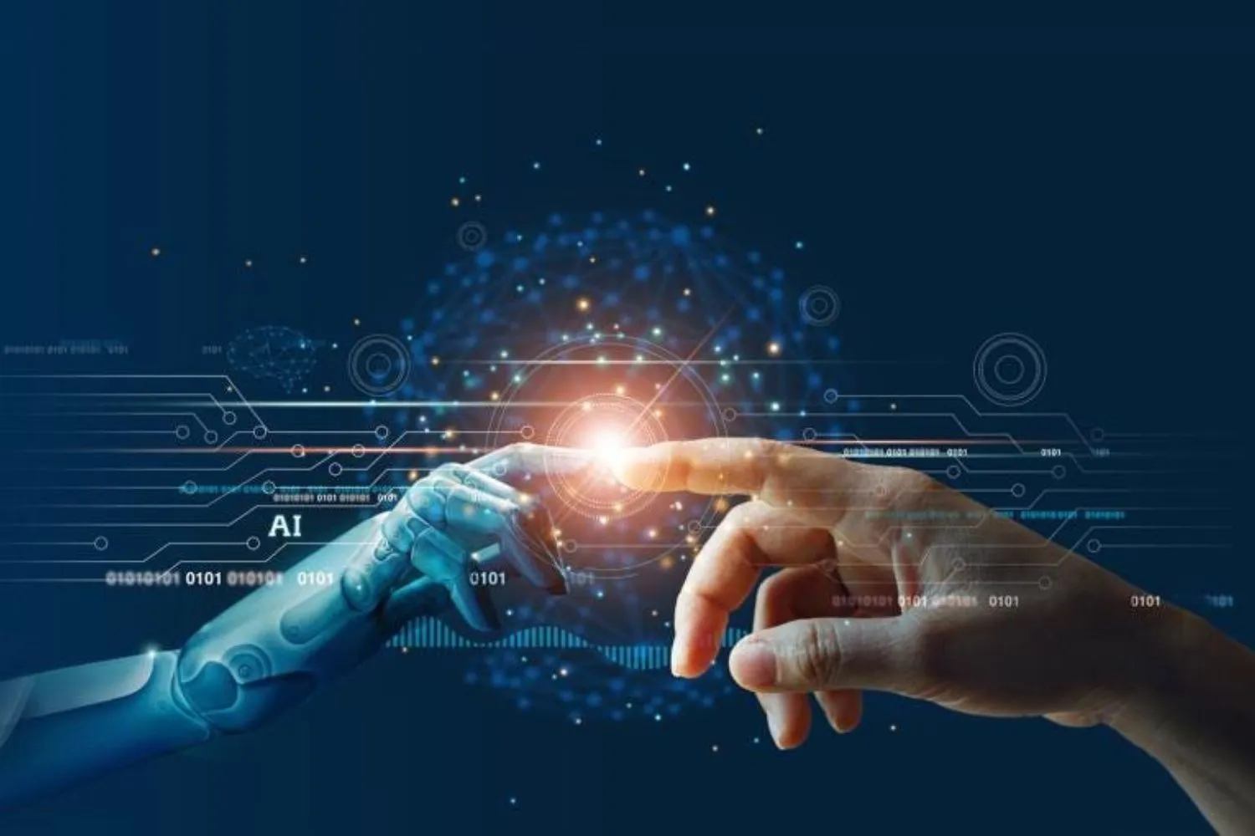

I LIVING LAB 33

ROBOTICS

**PORTFOLIO UPDATED EVERY WEEK**

Visual impairment

**Geovana Gomes**

GEOVANA GOMES

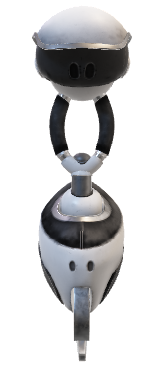I am a mechanical engineering student in love with life, who lives from the details that give meaning to human existence. I am a versatile person who appreciates subjects ranging from the technological and technical world of Mechanics to areas of more emotional and spiritual involvement such as literature and art. I enjoy my own company, but I don't miss spending quality time with people who add value to me and vice versa. I cannot underestimate the strong bond of friendship between a man and his dog. I experience this myself with my dogs.

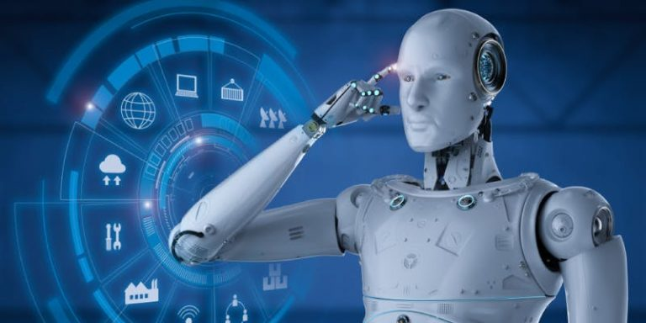

ILL 33

ILL will not only help my team and I improving ourselves, but everyone who may one day benefit from the ideas that will come to life in this 6 week period.

Onboarding week 1 4

Onboarding week 2 5

week 1 6

**WEEK 2** 9

WEEK 3 10

WEEK 4 12

WEEK 5 13

WEEK 6 15

# 

# Onboarding week 1

1. **Who am I and why have I registered for an ILL?**

I am Geovana Gomes a 22 years old student at MATE University in Hungary and I have registered for an ILL because I want to challenge myself, get out of my comfort zone, meet new people and open up for a new and a revolutionary mindset.

1. **What is my field of study?**

I am a Mechanical engineering student ’’technology field’’

1. **What do I plan to do after finishing my studies?**

I plan to look for a job in the technology field and bet on a several innovative projects

1. **Who/What motivates me?**

My family is my greatest motivator

1. **What do I do in my free time? / What am I passionate about?**

In my free time I usually read books, watch movies, walk, listen to music, watch various types of documentaries and podcasts and talk to friends and family. I am fascinated by languages and technology.

1. **What are my strengths?**

I am a person committed with work and I am always open to new ideas and suggestions and I like to learn and its process.

1. **What do I already know about the challenge topic (when/where/how did I first encounter it)?**

What I know about the topic is merely theoretical. I just think that AI is a great tool for disabled people and can make their lives easier in a variety of ways. AI can help them with activities of daily living by providing assistance with tasks such as mobility, medication reminders, and communication. AI can also provide access to information that is otherwise difficult to access, such as online education materials, job opportunities, and healthcare resources. AI can also provide companionship or emotional support to those with disabilities. For example, AI-powered robots can provide conversation and encourage social interaction, as well as help reduce loneliness and social isolation.

# 

# Onboarding week 2

1. **How was the Kick Off & 1. Onboarding Week for me?**

It was a week with expectations and fears, because it was the beginning of something totally new to me.

1. **Who is my reflection partner?**

For some reason, the partners have not yet been formed so far, but I believe it will be next week.

1. **How did self assessment on Future Skills go?**

I think it was reasonable and I'm optimistic about my progress.

1. **Which 3 Future Skills have I chosen & why?**

Life and Professional skills- The ILL is my first oppportunity to develop myself in this field, that i am still to inexperinced

Communication-I am an introverted and not so social person and this often gets in the way of my ability to communicate effectively

Critical thinking and problem solving- I think it is a skill that everyone should have and since  I have this opportunity to develop it more deeply, I am going to take advantege of it

1. **My current level & my goal level by the End of this ILL for each chosen Future Skill**

On a scale of 1 to 10 I would say that, for '' Life and Professional skills '' would be a 3 and my goal is 8 and for '' Communication'' it would be a 4 and I would like to achieve 8 and for '' Critical thinking and problem solving'' it would be a 6 to 8 as well. I made this rate because I need to be reasonable and realistic to myself, and saying 10 to these goals I would not be that reasonable.

1. **What have I find out in my desktop research?**

A recent example of Artificial Intelligence used to help disabled people is the Google AI initiative to build an AI wheelchair. The AI wheelchair uses computer vision and natural language processing to help disabled people navigate through their environment more autonomously. The AI wheelchair can also recognize and respond to facial expressions and detect objects in its environment. The AI wheelchair is still being tested and refined, but its initial results have been promising. It has been able to provide a much better independence and mobility for disabled people than before.

1. **What will I focus on next week?**

This week I will focus on finding the most appropriate and specific ideas possible so that they can be added to our project.

# week 1

1. **How was the 2. Onboarding Week for me? How did we as a Team begin?**

It was calm. I've been looking forward to learning more about our group dynamic and getting to know each member better. And as a team, ILL 33, in my opinion, started very well, because the members were very open up with each other and knew how to overcome the nervousness of working with completely new and unknown people, despite being the first contact in a more intimate way.

1. **Who is my new reflection partner?**

My reflection partner is Bonolo and I'm playing as Jules’s reflection partner.

1. **Which skills, knowledge, strengths will help me with the DT Process?**

I am a person committed to my tasks, I like to read, research and update myself in order to have a good position and opinion to give, I like to take advantage of any constructive and healthy opportunity to improve myself as a human being who wants to contribute to technological development and civic society. But perhaps most important of all is the fact that I am an empathetic person who cares for others, so I believe that the desire to help people with disabilities will be a great incentive for me to improve my DT process.

1. **What did I learn?**

I learned what it's like to work in a group, I learned that tolerance and respect for the opinion of my colleagues will be one of the pillars for the completion of a successful project.

1. **What surprised me?**

What surprised me was our coach who has an incredible personality, he is always willing to help and encourage us so that we are able to get to know each other and see pleasure in what we start accomplishing, even in small ways.

1. **My sparkling moment**

I think my sparkling moment was when I felt the urge to express myself with my colleagues and openly give my idea about what one of the rules in the group would be and also for suggesting that we think about researching people with autism to know how our project would be useful to them.

1. **What have I found out in my desktop research?**

I did research on the concept of disabilities on which we are thinking of developing our project**.**

**What is vision impairment?**

A vision impairment is defined as a limitation of one or more function of the eye, or visual system. This can range from mild vision impairment, to total blindness. It cannot be corrected to normal vision with prescriptive lenses or surgery.

A person with vision impairment may have some useful vision, referred to as functional or residual vision. However, the loss is severe enough to affect the ability to perform vocational, recreational and/or social tasks.

**What is hearing impairment?**

The term "hearing impaired" is often used to describe people with any degree of hearing loss, from mild to profound, including those who are deaf and those who are hard of hearing. Many individuals who are deaf or hard of hearing prefer the terms "deaf" and "hard of hearing," because they consider them to be more positive than the term "hearing impaired," which implies a deficit or that something is wrong that makes a person less than whole.

"Deaf" usually refers to a hearing loss so severe that there is very little or no functional hearing. "Hard of hearing" refers to a hearing loss where there may be enough residual hearing that an auditory device, such as a hearing aid or FM system, provides adequate assistance to process speech.

**What is autism?**

Autism spectrum disorder (ASD) is a developmental disability caused by differences in the brain. People with ASD often have problems with social communication and interaction, and restricted or repetitive behaviors or interests. People with ASD may also have different ways of learning, moving, or paying attention.

**What is dwarfism?**

Dwarfism is short stature that results from a genetic or medical condition. Dwarfism is generally defined as an adult height of 4 feet 10 inches (147 centimeters) or less. The average adult height among people with dwarfism is 4 feet (122 cm).

Many different medical conditions cause dwarfism. In general, the disorders are divided into two broad categories:

* **Disproportionate dwarfism.** If body size is disproportionate, some parts of the body are small, and others are of average size or above-average size. Disorders causing disproportionate dwarfism inhibit the development of bones.
* **Proportionate dwarfism.** A body is proportionately small if all parts of the body are small to the same degree and appear to be proportioned like a body of average stature. Medical conditions present at birth or appearing in early childhood limit overall growth and development.

**What is muteness**

Muteness or mutism is defined as an absence of speech while conserving or maintaining the ability to hear the speech of others. Mutism is typically understood as a person's inability to speak, and commonly observed by their family members, caregivers, teachers, doctors or speech and language pathologists. It may not be a permanent condition, as muteness can be caused or manifest due to several different phenomena, such as physiological injury, illness, medical side effects, psychological trauma, developmental disorders, or neurological disorders. A specific physical disability or communication disorder can be more easily diagnosed. Loss of previously normal speech (aphasia) can be due to accidents, disease, or surgical complication; it is rarely for psychological reasons.

Treatment or management also varies by cause, determined after a speech assessment. Treatment can sometimes restore speech. If not, a range of assistive and augmentative communication devices are available.

1. **What will I focus on next week?**

Next week I will focus on more specific aspects according to what will be discussed in the group on Monday.

<https://www.visability.com.au/about-visability/vision-resources/what-is-vision-impairment/>

<https://www.mayoclinic.org/diseases-conditions/dwarfism/symptoms-causes/syc-20371969>

<https://www.nhs.uk/conditions/autism/what-is-autism/>

<https://en.wikipedia.org/wiki/Muteness>

# **WEEK 2**

**How was the 1. ILL Week for me?**

The first week at ILL was productive and very interactive and as a group we came to a conclusion about what our target will be. We decided that our project will be about People with visual problems because we will have many more options of existing devices to be improved or adapted in order to help our target audience.

1. **What did I learn while reading other Portfolios?**

I learned that working in a group is very good because through the portfolios of my colleagues I could see the skills and strengths of each one that will be very useful when we distribute tasks. Now we know what each one identifies with the most, some are very creative, others enjoy using a lot of information because they are good researchers and others are more pragmatic, which reveals objectivity and clarity of their ideas

1. **What did I learn?**

I learned that it is very important to listen to what others have to say, but that I must be careful not to assume a passive posture.

1. **What surprised me?**

We didn't really have any big surprises during our meeting, I still appreciate the fact that we agreed so quickly on what we are going to do and what we want to do.

1. **What will I focus on next week?**

This week I will focus on how I can get in touch with a person with visual problems so that through an interview that person can provide us with some data about what kind of difficulties the visually impaired face and what the person thinks would be of great help.

1. **Which creative methods have I / we applied last week? How did that go?**

I used the exploratory research method and also talked to some friends about ILL and my team's task and my friends gave positive feedback. This motivated me a lot to research about devices that are available to help people with visual impairments and this made it a good contribution during our discussion on the subject. But the information I presented was researched in references found on the internet.

**Exploratory research:**

The purpose of exploratory research is to identify something, that is, a possible object of study or a problematization that could be the subject of future research.

**In this case, we are exploring objects that can be improved in the near future.**

# WEEK 3

**How was the 2. ILL Week for me?**

The second week was very interesting and productive because as a group we were able to establish more precise guidelines on how we are going to work. We focused a lot on the questions that would be asked in interviews with people with visual impairments and because of that we practiced a lot of empathy because in no way would we like to be impolite with these people because the real reason for our project is to help them to have a life easier and to feel more integrated in society despite their disability. We also researched some types of visual impairments that exist in order to understand how challenging it is to live with one of them. It was a week of real brainstorming and quite exciting!

**What have I found out about my reflecion partner?**

My reflection partner is Jules and I found him to be a very adaptable and dynamic person because he is willing to make changes in the way he interacts in order to be more productive for the team. And I think that's great for ILL 33, we should all be flexible and look to improve our way of working and that's what Jules did and showed in his portfolio.

**Which skills, knowledge, strenghts have I used already in the DT proces?**

Design thinking is a complex process that involves a lot of putting your skills into practice and seeking to develop others thinking about how to help others, so I:

* I tried to have a growth mindset.
* Practice empathy.
* Adaptability.
* Courage to imagine what it would be like to be a visually impaired person.

**What did I learn?**

I learned a lot about different technologies that can be used to help people with visual impairments and there are more appropriate technologies according to the type of visual impairment that the person has. And this is certainly an advantage for us because after the interviews we do, regardless of the most reported difficulty, we will have something to innovate and help them.

**What surprised me?**

What always surprises me is how the team works together. Everyone has something to say and a solution to the barrier that seems to arise and when we don't agree 100% on something, it's very simple for us to reach a consensus. And it also really surprised me that Catarina and Zack already have people on target to interview, that means progress for us because as soon as we get past the interview phase, we're going to move on to the technical part and I'm looking forward to it.

**What feedback did I get until now?**

I think Bonolo gave me good feedback saying I should look to make a more professional and creative portfolio and because of that I made some improvements and I hope she agrees with me.

**What will I focus on next week?**

For the next week I will focus on clearly conveying to the team the results of my task, which is to get in touch with an organization that works with blind people. I think I should organize what I will say to avoid inconsistency and the team can understand the information in the best possible way. In other words, effective communication will be my focus.

**How did Define phase go for me and for my team?**

I think the define phase went very well, now everyone at their compression level has a clear idea about what their duty is and what we really want to do and how to apply the Design thinghing.

# WEEK 4

1. **What progress did we make in the previous week?**

Last week we managed to conclude the empathetic phase and present all the results of our searches to find out about the personal, professional and daily challenges faced by people with visual impairments, the interviews carried out by Zack and Catarina helped us to better understand how a person in this condition feels and this is extremely important for our design thinking process.

1. **What was my contribution to that progress?**

I searched the internet for interviews with people with visual impairments and found some information that was included in our small record made by Zack in Canva. My research helped us to understand that people with visual impairments have a lot of difficulties in forming romantic relationships and that they also suffer a lot from the ignorance of others about their condition. Unfortunately, I did not get a response from the National Organization for Aid to the Disabled in Angola, so I looked for made interviews on internet.

1. **What did I learn?**

I learned that we need not only to be empathetic, but to know how to be empathetic so that our noble desire to help a blind person does not end up offending or hurting them, because despite being people who need help from other people, they need that help not to hurt their sense of human independence.

What did I learn about pitching?

1. **What surprised me?**

What surprised me is that the design thinking process is actually a very complex process, mainly because it implies the involvement of human feelings and not just the desire to find a solution for those in need.

What was my contribution to the pitch? What will we adopt/change for the final pitch?

**5. What will I do differently next week?**

This week I'm going to focus on the more technical and innovative part of our project, until now I've suppressed my ingenious self so that it wouldn't get in the way of understanding human feelings, but now it's time to start ideating a prototype that meets the challenge that we will choose on Wednesday.

# WEEK 5

1. **How is the cooperation with external stakeholder working?**

The cooperation with the stakeholder has gone well, although it is not a cooperation involving a specific person but with the blind whose challenge was launched by the need they face. I believe that the design thinking phase helped us a lot to understand our motivations in helping these people and the solutions we come up with are always based on meeting the needs of our Stakeholder.

1. **What feedback did I get from my reflection partner?**

I had very positive feedback from Bonolo about my portfolio. She said very nice things, she highlighted my evolution having mentioned that there is a positive improvement since when we started the ILL 33 class until now. She said that I know how to direct myself well and that my ideas are clear and that she can understand what I really wanted to convey. That makes me very happy because one of my biggest fears when we started ILL was not being able to communicate clearly and my colleagues couldn’t understand my point of view.

1. **Where & how am I going to apply this feedback in the future?**

I am sure that this feedback will be very useful to me at all times in my life when it is necessary to work as a team. This can be at the university with my classmates and professors, or at my future workplace with my co-workers. I think this feedback helps me to think better of others every time I need to present content. That goes beyond communicative skills, if not how I can do my best to help others and be an active member in any group.

1. **What did I learn?**

I learned that even living in the age of technology, people with disabilities, especially the blind, often do not have access to the technological adaptations necessary to make their lives less difficult. An example of this is the transport systems that can prove to be a stumbling block for blind people who seek to carry out their social activities. Which is why my team, and I are doing a lot of research on ways to help solve this problem in an efficient and sustainable way.

1. **What surprised me?**

What surprised me this week was seeing how my team now works in an even more synchronized way I think that understanding the difficulties that blind people face, made us more connected with each other and with our tasks within the group to avoid neglecting our responsibilities.

1. **What are we preparing for the final pitch?**

We spent a lot of time in the empathetic phase, so we started by just defining our core problem which is "Accessibility in public transport". And throughout the week we have been gathering many ideas that respond to this problem. We will gather them to be presented to the EEs and on Wednesday it is likely that we will define which solution we will work on to start designing maybe something that will be a prototype for the pitch.

# WEEK 6

1. A hand drawing a light bulb

   Description automatically generated with medium confidence**How was the last ILL week for me?**

The last week at ILL 33 was very productive for me, the team was able to come to the most important conclusions about what the poster and pitch would look like. I think that our project was able to take the shape we would like it to have so that when it was presented during the outboarding week there was no ambiguity and so all the other ILL groups could understand it, especially that the sponsors who with their help this idea can come to life and then make life easier for the visually impaired.

1. **Which skills, knowledge, strengths have I used in Design Thinking (DT) process?**

During the design thinking week, I used a lot my ability to do research, creativity, effective communication in the transmission of my ideas and research results, I also practiced the ability to listen to my colleagues' opinions, group work, brainstorming and commitment to the execution of my tasks.

1. **What did I learn (about me, about our topic...)?**

I learned about myself that I can be more productive and that I can manage my time well to fulfill my responsibilities and that when working on a topic that involves the well-being of others it is very important that I be empathic. I also learned that it is normal not to always know what to do and that in those moments I will always have the help of my colleagues. Our topic is very complex; however, I could see that this is a topic of concern for several people and organizations that have made available several technological resources in the market to help people with visual impairments.

1. **What surprised me?**

What surprised me was the dynamic and effective way my team worked to make all the ideas work together. It's impressive to see how people from different lines of reasoning work so synchronized.

1. **What is my part in creating a final pitch and a poster?**

During the creation of the Pitch and the Poster, I worked with Catarina and together we played the role of collecting existing software that would be integrated into the smart glasses and cane so that they would connect and work in sync. mockups were also created to show with the other software they would work to allow the blind person to travel, from the moment the person entered the data of his destination by voice, the purchase of tickets, accommodation inside the transport and the disembarkation of the same.

1. **How are we progressing as a team?**

As a team we gain a lot of sense of commitment and are always looking to provide good suggestions, communication has also improved a lot, we express our ideas and try to show respect for the ideas of others.